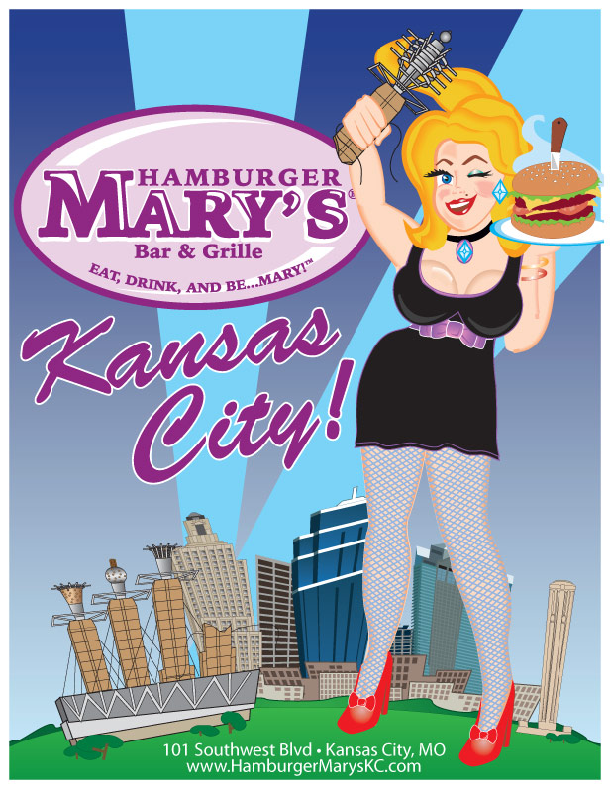
Presents: Ham-BINGO Charity Night for
The Kansas City Missouri Police Athletic League (P.A.L.)
Tuesday, December 17th 7:00pm-9:00pm
Registration starts at 6:00 so come early to register, find a seat, and eat!
Hamburger Mary’s is located at:
101 Southwest Boulevard
Kansas City, MO 64108
This is a fundraising event where guests can eat, drink and play bingo! There will be a suggested donation of 10 cards for $10. Of course you can always buy more if you like.
BINGO Prizes will be awarded!
Raffle items will also be available.

For more information please feel free to contact Marta Hayes (816)719-8448.
*The Bingo games can be a little risqué, but always in good fun. If you or your group is easily offended, this event may not be right for you!

