 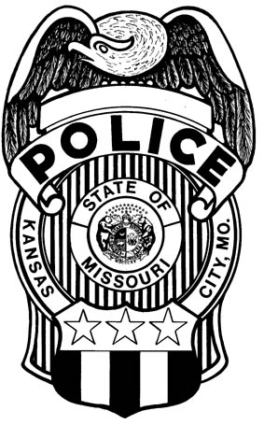

**Wellness**

**JUMP YOUR WAY TO BETTER HEALTH**

**PAL in conjunction with the Wellness Committee will be holding a jump rope competition**

**March 21st 8am to 6pm at the PAL Center**

**(1801 White Avenue, KCMO 64126)**

**$10.00 cash for participation**

**Plus Surge Cable Ropes for the top two finishers in each of the THREE CATEGORIES:**

**MOST SINGLE TURNS IN 1 MINUTE**

**MOST DOUBLE UNDERS IN 1 MINUTE**

**MAX CONSECUTIVE DOUBLE UNDERS WITHOUT A MISS**

**Register by March 12th by emailing** [**Benjamin.Lindsay@kcpd.org**](mailto:Benjamin.Lindsay@kcpd.org)

**(Please provide Ben with an approximate time you will be responding to compete)**