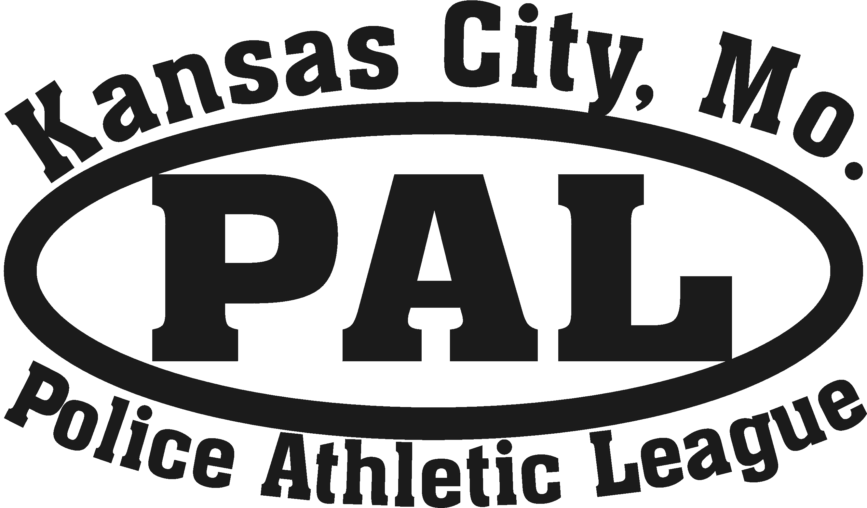

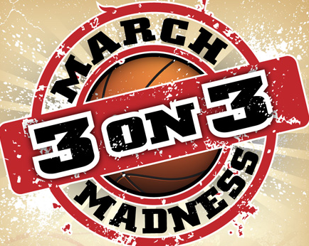
Basketball
March 22. 2014 1200 pm - 5pm located at the Police Athletic League 1801 White Ave KCMO 64128.
9th - 12th grade, $15 per team there, and no more than 15 teams. There will be pizza served after the games are over for the players that participated. For more info contact Coach Perez 816-719-8007

