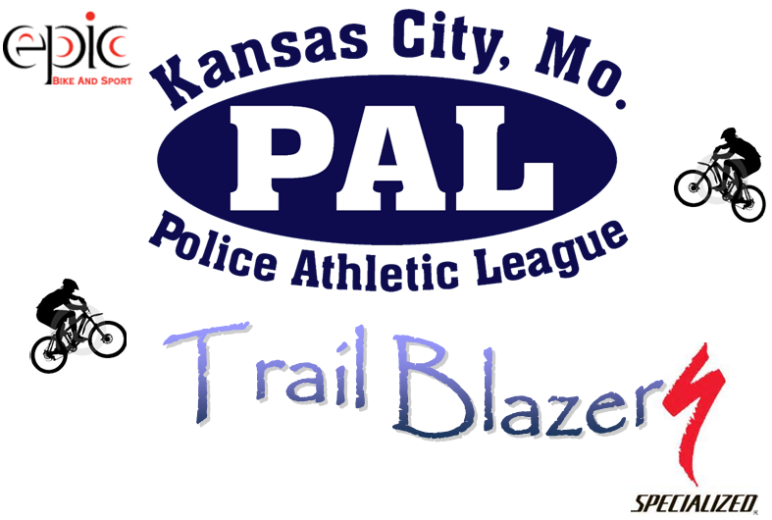

**JOIN US THURSDAY, MARCH 20TH AT 5PM**

**(1801 WHITE AVENUE KANSAS CITY, MISSOURI 64126)**

**PAL RECENTLY ACQUIRED NEW MOUNTAIN BIKES THANKS TO A SPECIALIZED GRANT AND EPIC BIKE AND SPORT.**

**COME CHECK OUT THESE NEW BIKES WHICH WILL BE ON DISPLAY AND HELP US THANK THE INDIVIDUALS THAT MADE THIS POSSIBLE.**